VOCABULARY & PHONETICS UNIT 10 (handout)
- Write the name of the appliances in the modem house.
1.  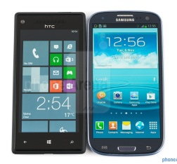  ............................................... | 2.  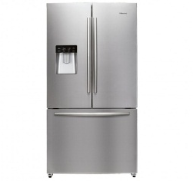  ...............................................
3.  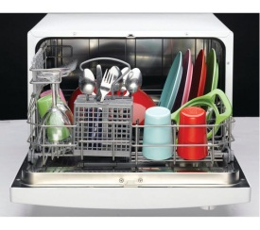  ............................................... | 4.  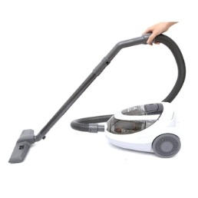  ...............................................
5.  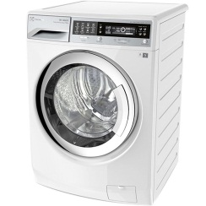  ............................................... | 6.  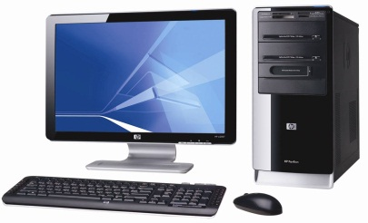  ...............................................
7.  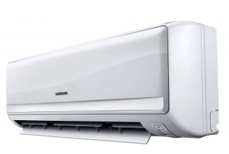  ............................................... | 8.  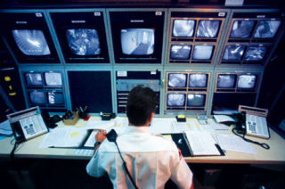  ...............................................

- Put the words in the correct category.
hi-tech robot  wireless TV  castle  skyscraper  houseboat | smart watch  motorhome  modern fridge  villa  cottage | automatic dishwasher  apartment  cable TV  automatic washing machine  palace

Type of houses | Appliances
..........................................................  ..........................................................  ..........................................................  ..........................................................  .......................................................... | ..........................................................  ..........................................................  ..........................................................  ..........................................................  ..........................................................
III. Choose the best option to fill in the blank.
1. People use _________ to wash clothes.
A. dishwashers B. fridges
C. washing machines D. wireless TV
2. We will live in a(n) _________ house in the future.
A. comfortable B. automatic C. wireless D. cable
3. My parents might buy an _________ dishwasher tomorrow.
A. comfortable B. automatic C. hi-tech D. cable
4. In the future, I will live in a _________ so that I can travel anywhere I want.
A. skyscraper B. palace C. motorhome D. houseboat
5. She might have a _________ to help her do the housework in the future.
A. fridge B. dishwasher C. washing machine D. robot
6. My aunt lives in a little _________ in the countryside.
A. palace B. cottage C. skyscraper D. castle
IV. Complete the gap with a suitable word.
      - _____________is a boat that is designed as a house.
      - ______________is a very tall building.
      - ______________ is a type of house usually for King and Queen to live in.
      - In winter, you usually use a__________________ to keep warm.
      - When you sweep the floor, instead of using a broom, you can use___________.
      - You use_____________ to iron your clothes.
      - In humid days, you use a______________ to make your wet clothes dry.
      - _______________is the highest floor of a building.
      - ______________is a vehicle that is designed as a house.
      - _______________is a block of apartments.
V. Put the words into two groups (/ dr / and / tr /)
dream travel drink drive tractor
trumpet dress tree trousers trip
draw train drip countryside stress

